**Community Grant Funding**   
**Guidance Document**

**This Guidance Document**

This document will set out the processes, procedures and requirements for the community grant funding that will be given through the Species Survival Fund. This will enable DWT to provide clarity and transparency to funding recipients and partners.

**DWT Vision & Strategy**

To meet the aims of DWT’s strategy of getting 1 in 4 people to act for wildlife we will mobilise communities to act by providing funding to local groups and in turn this will help lead natures recovery ensuring we secure 33% of land in Derbyshire for wildlife.

1. **Introduction to Wild Peak**

The Wild Peak is an ambitious rewilding initiative based in the Peak District that is working in close partnership with landowners, local communities and project leaders to inspire and implement a landscape-scale, nature-led approach to nature’s recovery, using nature based solutions and rewilding principles wherever possible.

Building on Lawton’s conservation principles of bigger, better, more and joined up, the project is working towards creating, restoring and connecting wild spaces across the region - working with and between existing initiates and conservation sites to create a nature recovery network.

1. **Our strategic outcomes**

Species Survival will increase capacity to create space managed for wildlife in Wild Peak. Image 1 shows the Wild Peak area we will be focusing on:

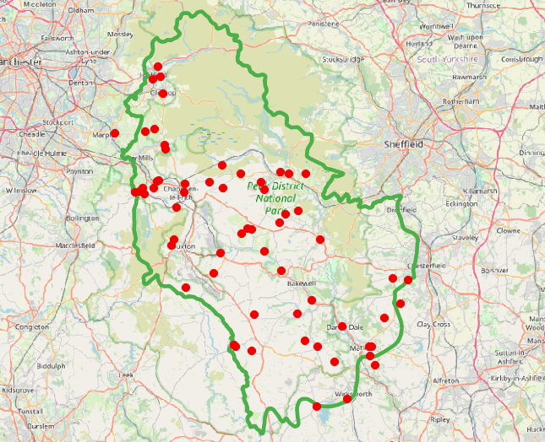

Green line – Wild Peak Boundary

Red points – Wild Peak sites

**Cont. Our strategic outcomes**

What we want to achieve:

- Nature’s recovery for species survival over the long-term

- A culture that values nature’s recovery

- A connected community, offering volunteer opportunities in practical conservation and citizen science (with associated health and wellbeing benefits)

- Connections between local leaders, community groups and landowners, to ensure a legacy of support after the project funding ends

1. **Purpose of the Community Grant Funding**

Connected communities are the ones who will deliver Species Survival in the long term.

Successful applicants will:

* Improve land for species abundance
* Target land that will help fill in gaps in the nature recovery network
* Consider the engagement benefits of interventions, prioritising land used by the community and visitors
* Consider how people can access areas of nature recovery

1. **Applying**

The Grant Fund will provide a minimum of 20 grants of up to £3000 each, minimum amount £500.

The panel will ensure a fair and just assessment of projects consistent with the funding priorities set out in this document.

There is an expectation that higher awards of funding will need to demonstrate more detailed planning, local support and greater alignment to DWT’s identified priorities to be successful. However, DWT want to ensure this funding is accessible for anyone to apply so will offer application support from the Wilder Connections Officer.

1. **Panel**

A panel has been appointed to ensure transparency and fairness in awarding the grants.

The panel will consist of representatives from:

Peak District National Park Authority  
High Peak Borough Council   
High Peak CVS   
Devonshire Group  
Transition New Mills

1. **The application process and awarding of grants**

The Species Survival Community Grant Funding Programme will be launched September 2024.This will stay open until March 2026. The panel will meet twice during the first year of the project, first in October 2024 and second in December 2024 with subsequent rounds of funding to be agreed after March 2025. Applicants can apply for more than one grant as long as the project focusses on a different site for nature recovery activities.

A dedicated application form will be used for all grant applications, which will enable applications to demonstrate how projects meet identified priorities and to outline the level of funding sought.

Application forms for the grants can be found online here

Selection and assessment criteria, to support decision making by the Grants Panel, have been developed. All projects will need to be able to meet the following criteria to be considered:

• Support designated land or area of interest to the Wild Peak Initiative

• Be time sustainable and not require ongoing funding from DWT

• Be delivered within agreed timescales from Sept 24 – Feb 26

• Show how the local community, landowners or local people have helped in the identification of activity or have been consulted/engaged

• Show what difference will be made

Applications that do not meet the criteria will not be put forward for consideration. Those that meet the selection criteria will be assessed by the panel. The assessment process will consider the evidence provided and the amount of funding requested, but in principle all funding will be assessed using the following broad assessment criteria:

• Meets the Species Survival Fund priorities and strategic outcomes

• Provides value for money

• Lasting impact and sustainability

Funding will be allocated on merit, considering which applications will have the largest impact locally and demonstrate the largest contribution to DWT’s priorities.

The Wilder Connections Officer will be delegated responsibility for presenting the applications to the panel for determination of award to ensure that funding can be issued for successful applications efficiently and effectively. We encourage applicants to speak with the Wilder Connections Officer for advice on applications.

If your application has been successful, DWT will contact the lead applicant and outline the conditions of funding.

1. **Evaluation**

Evaluation is extremely important, not only for the funders but to ensure the money is spent on the desired outcomes, but also for the applicants, to ensure they feel supported throughout the project.

All those in receipt of funding will be required to fill out an evaluation form at the completion of the project. Forms will be reviewed to ensure adequate monitoring evidence has been submitted. DWT may contact funding recipients for more evidence or clarification if required.